**Project Planning Phase**

**Project Planning Template (Product Backlog, Sprint Planning, Stories, Story points)**

|  |  |
| --- | --- |
| Date | 23rd May 2025 |
| Team ID | LTVIP2025TMID51767 |
| Project Name | FlightFInder |
| Maximum Marks | 5 Marks |

**Product Backlog, Sprint Schedule, and Estimation (4 Marks)**

Use the below template to create product backlog and sprint schedule

|  |  |  |  |  |  |  |
| --- | --- | --- | --- | --- | --- | --- |
| **Sprint** | **Functional**  **Requirement (Epic)** | **User Story**  **Number** | **User Story / Task** | **Story Points** | **Priority** | **Team Members** |
| Sprint-1 | User Authentication | USN-1 | As a user, I can register for the platform by entering my name, email, password, and confirming password. | 2 | High | Sativada chandini |
| Sprint-1 | User Authentication | USN-2 | As a user, I receive a confirmation email after registering. | 1 | High | Sativada chandini |
| Sprint-2 | User Authentication (OAuth) | USN-3 | As a user, I can register/login using Google OAuth. | 2 | Medium | Sativada chandini |
| Sprint-1 | Login | USN-4 | As a user, I can log into the platform using my email and password. | 1 | Medium | Sativada chandini |
| **Sprint** | **Functional**  **Requirement (Epic)** | **User Story**  **Number** | **User Story / Task** | **Story Points** | **Priority** | **Team Members** |
| Sprint-1 | Flight Dashboard | USN-5 | As a user, I can view available flights filtered by source, destination, and date. | 3 | High | Revanuru vaishnavi |
| Sprint-2 | Flight Dashboard | USN-6 | As a user, I can view my booking history and upcoming trips. | 2 | Medium | Revanuru vaishnavi |
| Sprint-3 | Flight Search + Booking | USN-7 | As a user, I can search for flights and select a seat before booking. | 2 | High | Revanuru vaishnavi |
| Sprint-3 | Cart | USN-8 | As a user, I can add a flight to my cart and update passenger details before checkout. | 2 | High | Revanuru vaishnavi |
| Sprint-3 | Checkout | USN- 9 | As a user, I can securely checkout and receive a booking confirmation email. | 3 | High | Sativada chandini |

**Project Tracker, Velocity & Burndown Chart: (4 Marks)**

|  |  |  |  |  |  |  |
| --- | --- | --- | --- | --- | --- | --- |
| Sprint-1 | 20 | 6 Days | 24 Apr 2025 | 29 Apr 2025 | 20 | 29 Apr 2025 |
| Sprint-2 | 20 | 6 Days | 31 Apr 2025 | 05 May 2025 | 20 | 05 May 2025 |
| Sprint-3 | 20 | 6 Days | 07 May 2025 | 12 May 2025 | 20 | 12 May 2025 |
| Sprint-4 | 20 | 6 Days | 14 May 2025 | 19 May 2025 | 20 | 19 May 2025 |

**Velocity:**

Imagine we have a 10-day sprint duration, and the velocity of the team is 20 (points per sprint). Let’s calculate the team’s average velocity (AV) per iteration unit (story points per day)

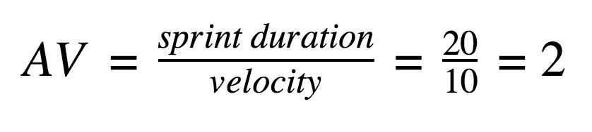

**Burndown Chart:**

A burn down chart is a graphical representation of work left to do versus time. It is often used in agile software development methodologies such as Scrum. However, burn down charts can be applied to any project containing measurable progress over time.

**https://www.visual-paradigm.com/scrum/scrum-burndown-chart/ https://www.atlassian.com/agile/tutorials/burndown-charts**

**Reference: https://www.atlassian.com/agile/project-management**

**https://www.atlassian.com/agile/tutorials/how-to-do-scrum-with-jira-software https://www.atlassian.com/agile/tutorials/epics https://www.atlassian.com/agile/tutorials/sprints**

**https://www.atlassian.com/agile/project-management/estimation https://www.atlassian.com/agile/tutorials/burndown-charts**